4 | elasticity
 Chapter

Answers to the Review Quizzes
Page 94
1. Why do we need a units-free measure of the responsiveness of the quantity demanded of a good or service to a change in its price?
The elasticity of demand is a units-free measure. Compare it as a measure of the responsiveness to some other candidate that depends on the units, such as the slope. The slope of the demand curve changes as the units measuring the same quantity of the good change (going from pounds to ounces, for example). The value of the elasticity is independent of the units used to measure the price and quantity of the product. As a result, the elasticity can be compared across the same good when quantity is measured in different units and/or the price is measured in different currencies. The elasticities of different goods also can be compared even though they are measured in different units.
2. Define the price elasticity of demand and show how it is calculated.
The price elasticity of demand is units-free measure of the responsiveness of the quantity demanded of a good to a change in its price when all other influences on buying plans remain the same. It equals the absolute value (or magnitude) of the ratio of the percentage change in the quantity demanded to the percentage change in the price. The percentage change in quantity (price) is measured as the change in quantity (price) divided by the average quantity (price).
3. What makes the demand for some goods elastic and the demand for other goods inelastic?
The magnitude of the price elasticity of demand for a good depends on three main influences:
• Closeness of substitutes. The more easily people can substitute other items for a particular good, the larger is the price elasticity of demand for that good.
• The proportion of income spent on the good. The larger the portion of the consumer’s budget being spent on a good, the greater is the price elasticity of demand for that good.
• The time elapsed since a price change. Usually, the more time that has passed after a price change, the greater is the price elasticity of demand for a good.
4. Why is the demand for a luxury generally more elastic (or less inelastic) than the demand for a necessity?
Demand for a necessity is generally less elastic than demand for a luxury because there are fewer substitutes for a necessity. Because there are more substitutes for a luxury than a necessity, the elasticity of demand for a luxury is larger is than the elasticity of demand for a necessity.
5. What is the total revenue test?
The total revenue test is a method of estimating the price elasticity of demand by observing the change in total revenue, given a change in price, holding all other things constant. The total revenue test shows that a price cut increases total revenue if demand is elastic, decreases total revenue if demand is inelastic, and does not change total revenue if demand is unit elastic.
Page 98
1. What does the income elasticity of demand measure?
The income elasticity of demand measures how the quantity demanded of a good responds to a change in income. The formula for the income elasticity of demand is the percentage change in the quantity of the good demanded divided by the percentage change in income.
2. What does the sign (positive/negative) of the income elasticity tell us about a good?
The sign of the income elasticity of demand reveals whether a good is a normal good or an inferior good: The income elasticity of demand is positive for normal goods and negative for inferior goods.
3. What does the cross elasticity of demand measure?
The cross elasticity of demand measures how the quantity demanded of one good responds to a change in the price of another good. The formula for the cross elasticity of demand is the percentage change in the quantity of the good demanded divided by the percentage change in the price of the related good.
4. What does the sign (positive/negative) of the cross elasticity of demand tell us about the relationship between two goods?
The sign of the cross elasticity of demand reveals whether two goods are substitutes or compliments: The cross elasticity of demand is positive for substitutes and negative for complements.
Page 100
1. Why do we need a units-free measure of the responsiveness of the quantity supplied of a good or service to a change in its price?
The elasticity of supply is a units-free measure. We need a units-free measure of the elasticity of supply for the same reason we need a units-free measure of the elasticity of demand: Because the value of the elasticity of supply is independent of the units used to measure the price and quantity of the good, the elasticity of supply can be compared across the same good when quantity is measured in different units and/or the price is measured in different currencies. In addition, the elasticities of supply of different goods also can be compared even though they are measured in different units.
2. Define the elasticity of supply and show how it is calculated.
The elasticity of supply measures the responsiveness of the quantity supplied to a change in the price of a good when all other influences on selling plans remain the same. The elasticity of supply is calculated by the percentage change in the quantity supplied divided by the percentage change in the price.
3. What are the main influences on the elasticity of supply that make the supply of some goods elastic and the supply of other goods inelastic?
The main influences on the elasticity of supply are:
• Resource substitution possibilities: the greater the suppliers’ ability to substitute resources, the greater will be their ability to react to price changes and the greater the elasticity of supply.
• Time frame for the supply decision: the greater the amount of time available after the price change, the greater is the suppliers’ ability to adjust quantity supplied, and the greater the elasticity of supply.
4. Provide examples of goods or services whose elasticities of supply are (a) zero, (b) greater than zero but less than infinity, and (c) infinity.
Here are some examples:
a) The momentary supply of wheat is perfectly inelastic. Once farmers have brought their wheat to market, there is no other alternative use for it and they sell it all regardless of the going price.
b) The short-run supply of wheat. If the farmers already have a mature wheat crop but have not yet harvested it, farmers with both relatively high and low yield fields may chose to harvest both types of fields if the price for wheat is high. However, the farmers will not harvest their low yield fields when the price of wheat is relatively low to economize on added labor costs.
c) The supply of wheat to an individual buyer. Any one buyer can purchase as much wheat at the going price as he or she desires. However, no quantity of wheat will be supplied at a lower price.
5. How does the time frame over which a supply decision is made influence the elasticity of supply? Explain your answer.
The momentary supply, short-run supply, and long-run supply all illustrate the response of suppliers to changes in the price, but they differ according to how much time has elapsed after the price change.
• The momentary supply is frequently the least elastic and shows how suppliers cannot easily respond to a price change immediately after the price change occurs. Changing the quantity produced means changing the inputs into the production process, which takes time to complete. Sometimes the momentary supply is perfectly inelastic.
• The short-run supply shows suppliers’ response after enough time has elapsed for some, but not all, of the possible technological adjustments have occurred. Short-run supply generally is intermediate in elasticity between the momentary supply and the long-run supply.
• The long-run supply shows how suppliers react after enough time has passed that all possible adjustments to factors of production have been made to accommodate the price change. It usually is the most elastic of the three supplies.
Answers to the Study Plan Problems and Applications
1. Rain spoils the strawberry crop, the price rises from $4 to $6 a box, and the quantity demanded decreases from 1,000 to 600 boxes a week.
a. Calculate the price elasticity of demand over this price range.
The price elasticity of demand is 1.25. The price elasticity of demand equals the percentage change in the quantity demanded divided by the percentage change in the price. The price rises from $4 to $6 a box, a rise of $2 a box. The average price is $5 a box. So the percentage change in the price is $2 divided by $5 and then multiplied by 100, which equals 40 percent. The quantity decreases from 1,000 to 600 boxes, a decrease of 400 boxes. The average quantity is 800 boxes. So the percentage change in quantity is 400 divided by 800, which equals 50 percent. The price elasticity of demand for strawberries is 50 percent divided by 40 percent, which equals 1.25.
b. Describe the demand for strawberries.
The price elasticity of demand exceeds 1, so the demand for strawberries is elastic.
2. If the quantity of dental services demanded increases by 10 percent when the price of dental services falls by 10 percent, is the demand for dental services inelastic, elastic, or unit elastic?
The demand for dental services is unit elastic. The price elasticity of demand for dental services equals the percentage change in the quantity of dental services demanded divided by the percentage change in the price of dental services. The price elasticity of demand is 10 percent divided by 10 percent, which equals 1. The demand is unit elastic.
3. The demand schedule for hotel rooms is in the table.
Price  (dollars  per night) | Quantity demanded  (millions of  rooms per night)
200 | 100
250 | 80
400 | 50
500 | 40
800 | 25
a. What happens to total revenue when the price falls from $400 to $250 a room per night and from $250 to $200 a room per night?
When the price is $400, the total revenue is equal to $400 × 50 million rooms, or $20 billion. When the price is $250, the total revenue is equal to $250 × 80 million rooms, or $20 billion. So the total revenue does not change when the price falls from $400 to $250 a night.
When the price is $250, the total revenue is equal to $250 × 80 million rooms, or $20 billion. When the price is $200, the total revenue is equal to $200 × 100 million rooms, or $20 billion. So the total revenue does not change when the price falls from $400 to $250 a night.
b. Is the demand for hotel rooms elastic, inelastic or unit elastic?
The total revenue is the same at all prices, $20 billion. Because a change in price does not change the total revenue at any price, the demand is unit elastic at all prices.
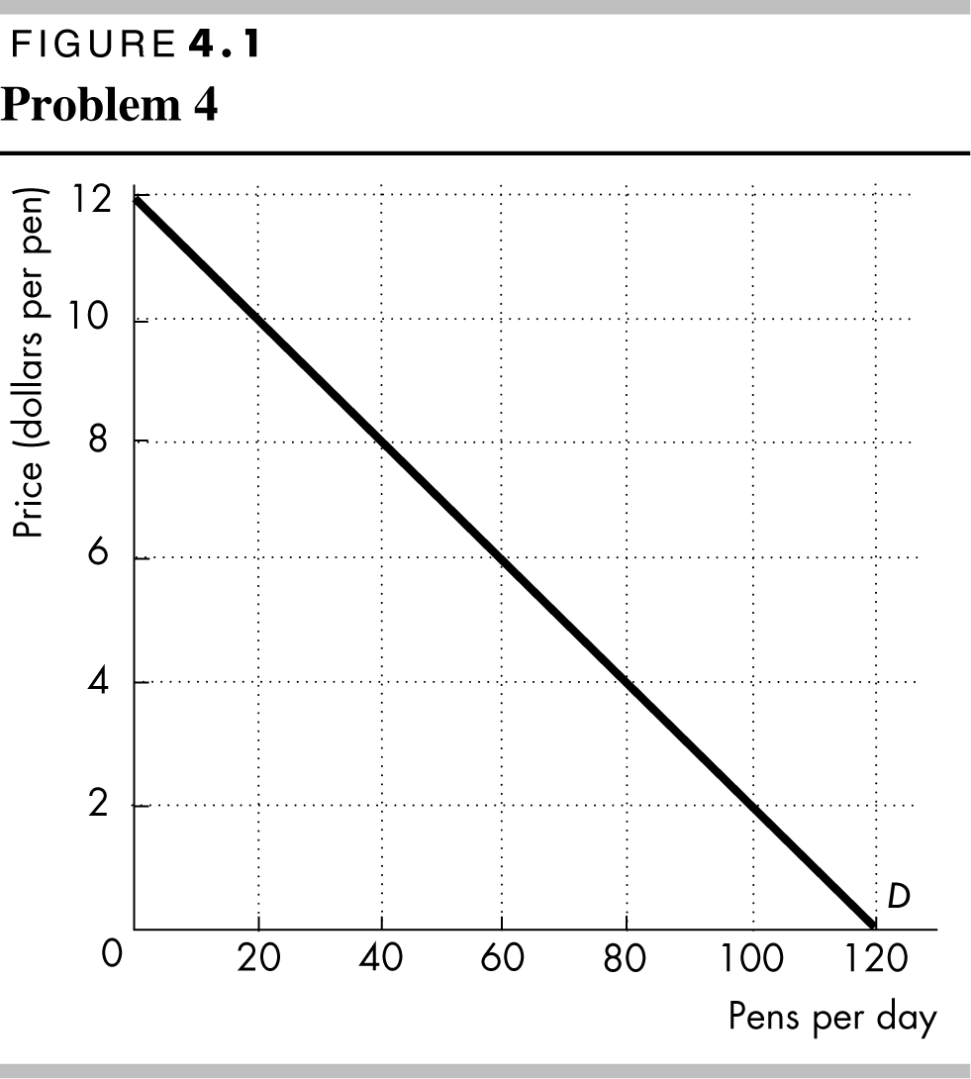
4. The figure shows the demand for pens.
Calculate the elasticity of demand when the price rises from $4 to $6 a pen. Over what price range is the demand for pens elastic?
The price elasticity of demand is 0.72. When the price of a pen rises from $4 to $6, the quantity demanded of pens decreases from 80 to 60 a day. The price elasticity of demand equals the percentage change in the quantity demanded divided by the percentage change in the price. The price increases from $4 to $6, an increase of $2 a pen. The average price is $5 per pen. So the percentage change in the price equals $2 divided by $5 and then multiplied by 100, which equals 40 percent. The quantity decreases from 80 to 60 pens, a decrease of 20 pens. The average quantity is 70 pens. So the percentage change in quantity demanded equals 20 divided by 70 and then multiplied by 100, which equals 28.6 percent. The price elasticity of demand for pens equals 28.6 percent divided by 40 percent, which is 0.72.
The demand for pens is elastic at all prices higher than the price at the midpoint of the demand curve, which indicates that the demand for pens is elastic at prices between $12 per pen and $6 per pen.
5. In 2015, an outbreak of Avian Flu decreased the quantity of eggs produced by 18 percent. A shortage of eggs was avoided by a rise in their wholesale price from $1.34 to $2.40 per dozen.
a. If the demand for eggs didn’t change, what is your estimate of the price elasticity of demand for eggs?
Using the data in the question, the price elasticity of demand is 0.32. The change in the price is $1.06 and the average of the two prices is $1.87, so the percentage change in the price is ($1.06/$1.87) × 100, which equals 56.7 percent. The increase in the quantity demanded was 18 percent. The price elasticity of demand equals (18.0 percent)/(56.7 percent), or 0.32.
b. Thinking about the influences on the price elasticity of demand, why would you expect the demand for eggs to be inelastic?
The smaller the proportion of income spent on a good, the smaller the elasticity of demand for that good. In many circumstances, the amount of a person’s income spent on eggs is small, so that the demand for eggs is inelastic.
6. When Judy’s income increased from $130 to $170 a week, she increased her demand for concert tickets by 15 percent and decreased her demand for bus rides by 10 percent. Calculate Judy’s income elasticity of demand for (a) concert tickets and (b) bus rides.
The income elasticity of demand for (a) concert tickets is 0.56 and (b) bus rides is −0.375. The income elasticity of demand equals the percentage change in the quantity demanded divided by the percentage change in income. The change in income is $40 and the average income is $150, so the percentage change in income equals 26.7 percent.
a. The change in the quantity demanded of concert tickets is 15 percent. The income elasticity of demand for concert tickets equals 15/26.7, which is 0.56.
b. The change in the quantity demanded of bus rides is −10 percent. The income elasticity of demand for bus rides equals −10/26.7, which is −0.375.
7. If a 12 percent rise in the price of orange juice decreases the quantity of orange juice demanded by 22 percent and increases the quantity of apple juice demanded by 14 percent, calculate the
a. Price elasticity of demand for orange juice.
The price elasticity of demand for orange juice is 1.83. The price elasticity of demand is the percentage change in the quantity demanded of the good divided by the percentage change in the price of the good. So the price elasticity of demand equals 22 percent divided by 12 percent, which is 1.83.
b. Cross elasticity of demand for apple juice with respect to the price of orange juice.
The cross elasticity of demand between orange juice and apple juice is 1.17. The cross elasticity of demand is the percentage change in the quantity demanded of one good divided by the percentage change in the price of another good. So the cross elasticity of demand is the percentage change in the quantity demanded of apple juice divided by the percentage change in the price of orange juice. The cross elasticity equals 14 percent divided by 12 percent, which is 1.17.
8. If a rise in the price of sushi from 98¢ to $1.02 a piece decreases the quantity of soy sauce demanded from 101 units to 99 units an hour and decreases the quantity of sushi demanded by 1 percent an hour, calculate the:
a. Price elasticity of demand for sushi.
The price of sushi rises by ($1.02 − $0.98)/$1.00 = 4 percent. Therefore the price elasticity of demand for sushi equals |( −1 percent)/(4 percent)|, which is 0.25.
b. Cross elasticity of demand for soy sauce with respect to the price of sushi.
The quantity of soy sauce decreases by (99 – 101)/100 = −2 percent. Therefore the cross elasticity of demand for soy sauce with respect to the price of sushi equals |( −2 percent)/(4 percent), which is −0.5.
9. The table sets out the supply schedule of jeans.
Price  (dollars  per pair) | Quantity supplied  (millions of  pairs per year)
120 | 24
125 | 28
130 | 32
135 | 36
a. Calculate the elasticity of supply when the price rises from $125 to $135 a pair.
The elasticity of supply equals the percentage change in the quantity supplied divided by the percentage change in price. The percentage change in the quantity demanded equals [(36 − 28)/32] × 100, which is 25.0 percent. The percentage change in the price equals [($135 − $125)/$130] × 100, which is 7.7 percent. The elasticity of supply equals (25.0 percent/7.7 percent), which is 3.25.
b. Calculate the elasticity of supply when the average price is $125 a pair.
To find the elasticity at an average price of $125 a pair, change the price such that $125 is the average price—for example, a rise in the price from $120 to $130 a pair. To calculate the elasticity when the average price is $125, calculate the elasticity over the price range from $120 to $130. The percentage change in the quantity demanded equals [(32 − 24)/28] × 100, which is 28.6 percent. The percentage change in the price equals [($130 − $120)/$125] × 100, which is 8.0 percent. The elasticity of supply equals (28.6 percent/8.0 percent), which is 3.58.
c. Is the supply of jeans elastic, inelastic, or unit elastic?
The supply of jeans is elastic.

Answers to Additional Problems and Applications
10. With higher fuel costs, airlines raised their average fare from 75¢ to $1.25 per passenger mile and the number of passenger miles decreased from 2.5 million a day to 1.5 million a day.
a. What is the price elasticity of demand for air travel over this price range?
The price elasticity of demand equals the percentage change in the quantity demanded divided by the percentage change in the price. The quantity demanded changes by 1.0 million passenger miles and the average passenger miles is 2.0 million. The percentage change in the quantity demanded is (1.0 million)/(2.0 million) × 100, which is 50 percent. The price changes by $0.50 and the average price is $1.00. The percentage change in the quantity demanded is ($0.50 /($1.00) × 100, which is 50 percent. So the price elasticity of demand is (50 percent)/(50 percent), or 1.00.
b. Describe the demand for air travel.
The demand for air travel between these two prices is unit elastic. The 50 percent price hike leads to a 50 percent decrease in the quantity of air miles traveled.
11. Figure 4.2 shows the demand for DVD rentals.
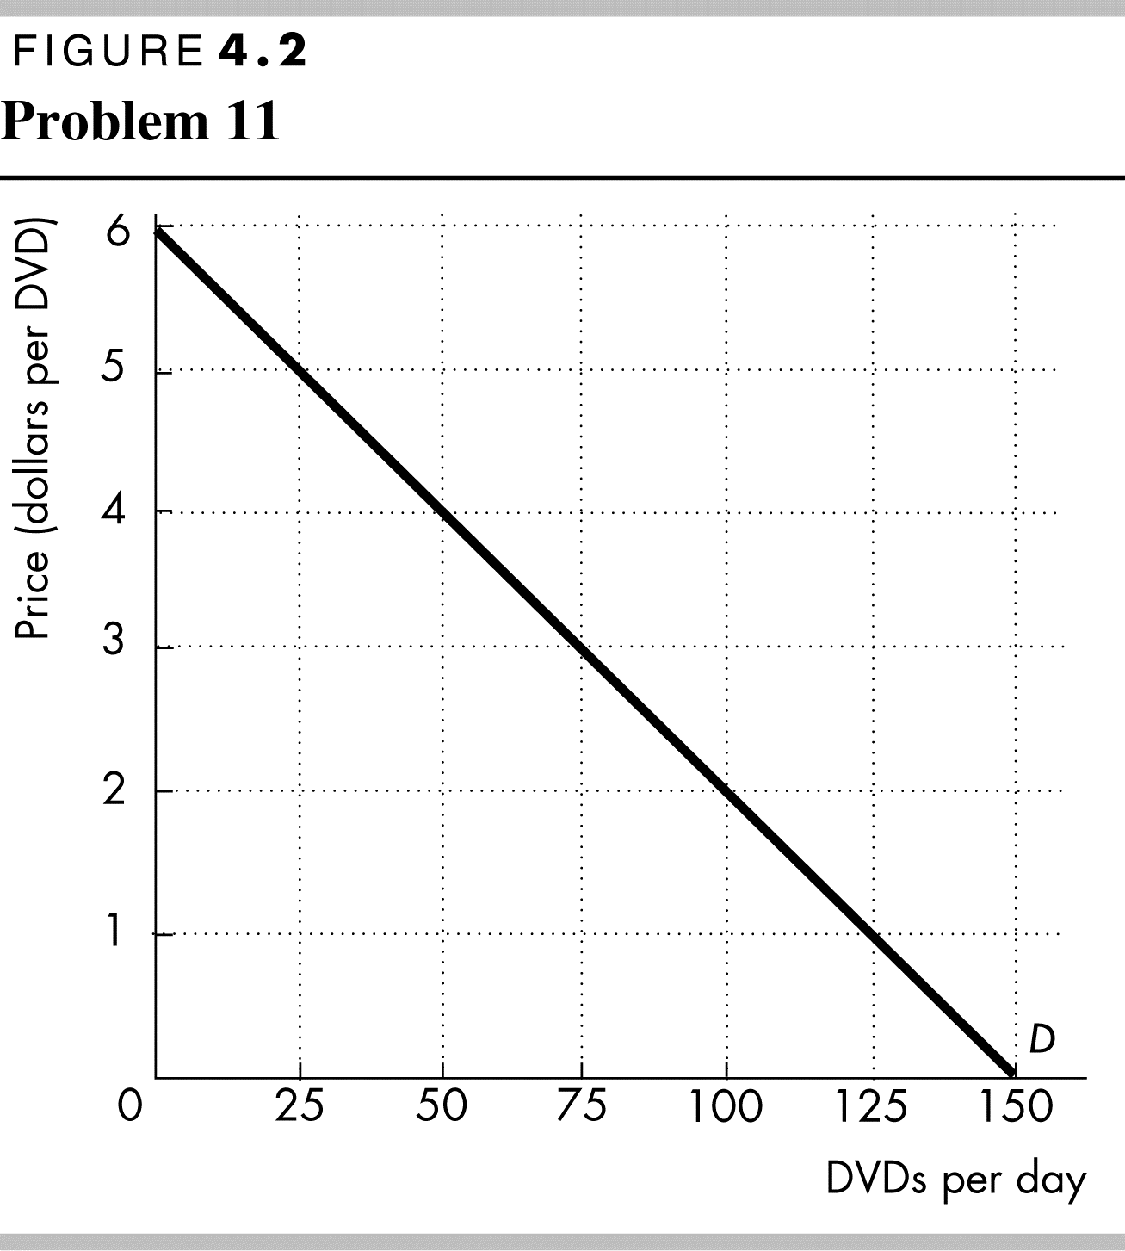
a. Calculate the elasticity of demand when the price of a DVD rental rises from $3 to $5.
The price elasticity of demand is 2. When the price of a DVD rental rises from $3 to $5, the quantity demanded of DVDs decreases from 75 to 25 a day. The price elasticity of demand equals the percentage change in the quantity demanded divided by the percentage change in the price. The price increases from $3 to $5, an increase of $2 a DVD. The average price is $4 per DVD. So the percentage change in the price equals $2 divided by $4 and then multiplied by 100, which equals 50 percent. The quantity decreases from 75 to 25 DVDs, a decrease of 50 DVDs. The average quantity is 50 DVDs. So the percentage change in quantity demanded equals 50 divided by 50 and then multiplied by 100, which equals 100 percent. The price elasticity of demand for DVD rentals equals 100 percent divided by 50 percent, which is 2.
b. At what price is the elasticity of demand for DVD rentals equal to 1?
The price elasticity of demand equals 1 at $3 a DVD. The price elasticity of demand equals 1 at the price halfway between the origin and the price at which the demand curve intersects the y-axis. That price is $3 a DVD.
Price  (dollars  per chip) | Quantity demanded  (millions of  chips per year)
200 | 50
250 | 45
300 | 40
350 | 35
400 | 30
Use the following table to work Problems 12 to 14.
The demand schedule for computer chips is in the table.
12. a. What happens to total revenue if the price falls from (i) $400 to $350 a chip and from (ii) $350 to $300 a chip?
(i) When the price of a chip is $400, 30 million chips are sold and total revenue equals $12,000 million. When the price of a chip falls to $350, 35 million chips are sold and total revenue is $12,250 million. The total revenue increases when the price falls.
(ii) When the price is $350 a chip, 35 million chips are sold and total revenue is $12,250 million. When the price of a chip is $300, 40 million chips are sold and total revenue decreases to $12,000 million. The total revenue decreases as the price falls.
b. At what price is total revenue at a maximum?
Total revenue is maximized at $350 a chip. When the price of a chip is $300, 40 million chips are sold and total revenue equals $12,000 million. When the price is $350 a chip, 35 million chips are sold and total revenue equals $12,250 million. Total revenue increases when the price rises from $300 to $350 a chip. When the price is $400 a chip, 30 million chips are sold and total revenue equals $12,000 million. Total revenue decreases when the price rises from $350 to $400 a chip. Total revenue is maximized when the price is $350 a chip.
13. At an average price of $350, is the demand for chips elastic, inelastic, or unit elastic? Use the total revenue test to answer this question.
The demand for chips is unit elastic. The total revenue test says that if the price changes and total revenue remains the same, the demand is unit elastic at the average price. For an average price of $350 a chip, cut the price from $400 to $300 a chip. When the price of a chip falls from $400 to $300, the total revenue remains at $12,000 million. So at the average price of $350 a chip, demand is unit elastic.
14. At $250 a chip, is the demand for chips elastic or inelastic? Use the total revenue test to answer this question.
The demand for chips is inelastic. The total revenue test says that if the price falls and total revenue falls, the demand is inelastic. When the price falls from $300 to $200 a chip, total revenue decreases from $12,000 million to $10,000 million. So at an average price of $250 a chip, demand is inelastic.
15. Your price elasticity of demand for bananas is 4. If the price of bananas rises by 5 percent, what is
a. The percentage change in the quantity of bananas you buy?
The quantity of bananas you buy decreases by 20 percent. The price elasticity of demand equals the percentage change in the quantity demanded divided by the percentage change in the price. Rearranging this formula shows that the percentage change in the quantity demanded equals the price elasticity of demand multiplied by the percentage change in the price. The percentage change in the quantity demanded equals 4 × 5 percent, which is 20 percent.
b. The change in your expenditure on bananas?
Your total expenditure decreases because your demand is elastic. The fall in expenditure is approximately 15 percent, the 5 percent rise in price offset by the 20 percent decrease in the quantity purchased.
16. Memorial Day Gas Cheapest in a Decade
Gasoline prices are at their lowest in a decade. The average price in Orangeburg is $2.05 a gallon, 35¢ lower than last year. In a recent AAA survey, 55 percent of Americans said they are more likely to take a road trip this year due to lower gas prices. About 1.5 million Carolinians are expected to drive to their Memorial Day destinations, up 2.1 percent over last year.
Source: The Times and Democrat, May 27, 2016
a. What are the elasticities of demand implicitly referred to in the news clip.
The elasticity of demand that the article references is the price elasticity of demand. The article mentions how drivers respond to the fall in the price of gasoline by increasing the quantity of their road trips.
b. Calculate the price elasticity of demand for road trips using the data in the news clip.
The price elasticity of demand for road trips equals the percentage change in the quantity demanded, 2.1 percent, divided by the percentage change in the price of gasoline. The average price fell 35¢ from $2.40 to $2.05, which makes the average price $2.23. So the percentage change in the price is (0.35/2.23) × 100 or 15.7 percent. Consequently the price elasticity of demand for road trips equals (2.1 percent/15.7 percent) or 0.13.
Use this information to work Problems 17 and 18.
Public Transit Ridership Is Down
Public transit ridership was down in 2016 in most U.S. cities. Uber rides increased and gas prices fell. In some cities, transit service became unreliable.
Source: WBUR, March 21, 2017
17. List and explain the elasticities of demand implicitly referred to in the news clip.
The article implicitly refers to two cross elasticities of demand: The cross elasticity of demand for transit rides with respect to the price of gasoline and the cross elasticity of demand for Uber rides with respect to the price of gasoline.
18. Are transit tickets, Uber rides, and gasoline substitutes? Explain your answer.
Transit tickets and gasoline are substitutes. As the price of gasoline fell, the demand for transit tickets decreased, so the cross elasticity of demand is positive. Uber rides and gasoline are complements because as the price of gasoline fell, the demand for Uber rides increased, so the cross elasticity of demand is negative.
19. When Alex’s income was $3,000, he bought 4 bagels and 12 donuts a month. Now his income is $5,000 and he buys 8 bagels and 6 donuts a month. Calculate Alex’s income elasticity of demand for (a) bagels and (b) donuts.
a. The income elasticity of demand equals the percentage change in the quantity demanded divided by the percentage change in income. The change in income is $2,000 and the average income is $4,000, so the percentage change in income equals 50 percent. The change in the quantity demanded is 4 bagels and the average quantity demanded is 6 bagels, so the percentage change in the quantity demanded equals 66.67 percent. The income elasticity of demand for bagels equals (66.67 percent)/(50 percent), which is 1.33.
b. From part (a), the percentage change in income is 50 percent. The change in the quantity demanded is −6 donuts and the average quantity demanded is 9 donuts, so the percentage change in the quantity demanded is −66.67 percent. The income elasticity of demand for donuts equals (−66.67 percent)/(50 percent), which is −1.33.
20. How Much Does an American Wedding Cost?
A survey by The Knot reports the national average cost of a wedding, excluding the honeymoon, was $35,329 in 2016, up from $32,641 in 2015 and $31,213 in 2014. Incomes rose every year.
Source: The Motley Fool, February 20, 2017
a. Do the data imply that a wedding event is a normal good or an inferior good? Explain.
Based on the news clip, wedding events are a normal good. As incomes increased, the demand for wedding events also increased.
b. Is a wedding event more a necessity or a luxury? Would the income elasticity of demand be greater than 1, less than 1, or equal to 1? Explain your answer.
Wedding events are a luxury. Wedding events are not necessities because couples can marry with plain weddings; indeed, couples can marry using a civil ceremony and with no wedding event at all. If wedding events are a luxury, their income elasticity of demand is greater than 1.
21. Pet Care is a True Recession-Proof Industry
Two out of three Americans own a pet—almost half own a dog and a third a cat—and pet ownership is projected to grow. Households have spent more on pets every year through recessions and booms, growing from $17 billion in 1994 to near $63 billion in 2016. People are clearly willing to pay pet expenses even in hard times, and there’s no reason to expect that to change in the next recession.
Source: Business Insider, January 28, 2017
a. What does this news clip imply about the income elasticity of demand for pet food and pet care products?
The news clip implies that both pet food and pet care products are necessities. Their income elasticities of demand are positive but very small (since they are a “true recession-proof industry”).
b. Would the income elasticity of demand for pet food and pet care products be greater or less than 1? Explain.
The income elasticities of demand are less than 1 because they are necessities.
22. If a 5 percent fall in the price of chocolate sauce increases the quantity demanded of chocolate sauce by 10 percent and increases the quantity of ice cream demanded by 15 percent, calculate the:
a. Price elasticity of demand for chocolate sauce.
The price elasticity of demand for chocolate sauce equals the percentage change in the quantity of chocolate sauce demanded divided by the percentage change in the price of chocolate sauce. Using the data in the problem, the price elasticity of demand equals (10 percent)/(−5 percent), which is 2.0.
b. Cross elasticity of demand for ice cream with respect to the price of chocolate sauce.
The cross elasticity of demand for ice cream with respect to the price of chocolate sauce equals the percentage change in the quantity of ice cream demanded divided by the percentage change in the price of chocolate sauce. Using the data in the problem, the cross elasticity of demand equals (15 percent)/(−5 percent), which is −3.0. Ice cream and chocolate sauce are complements.
23. The table sets out the supply schedule of long-distance phone calls. Calculate the elasticity of supply when
Price  (cents  per minute) | Quantity supplied  (millions of  minutes per day)
10 | 200
20 | 400
30 | 600
40 | 800
a. The price falls from 40¢ to 30¢ a minute.
The elasticity of supply is 1. The elasticity of supply is the percentage change in the quantity supplied divided by the percentage change in the price. When the price falls from 40 cents to 30 cents, the change in the price is 10 cents and the average price is 35 cents. The percentage change in the price is 28.57 percent. When the price falls from 40 cents to 30 cents, the quantity supplied decreases from 800 to 600 calls. The change in the quantity supplied is 200 calls, and the average quantity is 700 calls, so the percentage change in the quantity supplied is 28.57 percent. The elasticity of supply equals (28.57 percent)/(28.57 percent), which is 1.
b. The average price is 20¢ a minute.
The elasticity of supply is 1. The formula for the elasticity of supply calculates the elasticity at the average price. So to find the elasticity at an average price of 20 cents a minute, change the price such that 20 cents is the average price—for example, a fall in the price from 30 cents to 10 cents a minute. When the price falls from 30 cents to 10 cents, the change in the price is 20 cents and the average price is 20 cents. The percentage change in the price is 100 percent. When the price falls from 30 cents to 10 cents, the quantity supplied decreases from 600 to 200 calls. The change in the quantity supplied is 400 calls and the average quantity is 400 calls. The percentage change in the quantity supplied is 100 percent. The elasticity of supply is the percentage change in the quantity supplied divided by the percentage change in the price. The elasticity of supply is 1.
24. Coal Production and Coal Price Down
U.S. coal production in 2016 is 17 percent down on that of 2015. Almost all coal use in the United States is for electricity generation and the price of coal for power plants fell from $2.27 per million Btu in 2015 to $2.17 per million Btu in 2016.
Source: Hellenic Shipping News, January 10, 2017
Calculate the price elasticity of supply of coal assuming no change in the supply of coal. Is the supply of coal elastic or inelastic?
The price elasticity of supply of coal equals the percentage change in the quantity of coal supplied divided by the percentage change in the price of coal. The data in the problem gives the percentage change in the quantity supplied as −17 percent. The change in the price is $0.10 and the average price is $2.22, so the percentage change in the price equals ($0.10/$2.22) × 100, or 4.5 percent. Consequently, the price elasticity of supply equals (–17 percent)/( –4.5 percent), which is 3.78. The elasticity exceeds 1.0 in value, so the supply of coal is elastic.
Economics in the News
25. After you have studied Economics in the News on pp. 102–103, answer the following questions.
a. Use the information in the news article to estimate the cross elasticity of demand for water with respect to the price of sugar-sweetened drinks.
The cross elasticity of demand for water with respect to the price of sugar-sweetened drinks equals the percentage change in the demand for water divided by the percentage change in the price of sugar-sweetened drinks. The article notes that the demand for water increased by 63 percent and the analysis after the article calculated that the price of sugar-sweetened drinks rose by ($0.14/$1.82) × 100, or 7.7 percent. So, the cross elasticity of demand for water with respect to the price of sugar-sweetened drinks equals (63 percent/7.7 percent) or 8.2.
b. How does the total revenue test work for a rise in price? What do you predict happened to total revenue from sugar-sweetened drinks when the tax was imposed on them? Why?
The total revenue test concludes that when the price rises, the total revenue decreases if demand is elastic, does not change if demand is unit elastic, and increases if demand is inelastic. The analysis of the article demonstrated that the demand for the sugar-sweetened drinks is elastic, so the total revenue from sugar-sweetened drinks decreased.
c. Would you expect the elasticity of demand for Coke, or Gatorade, or Red Bull, or Hawaiian Punch to be the same as the elasticity of demand for sugar-sweetened drinks? Explain why or why not.
The price elasticity of demand for the several drinks named is larger than the price elasticity of demand for sugar-sweetened drinks. The drinks are a narrowly defined good, so they have many close substitutes such as Pepsi, Powerade, Rockstar, and Tropicana Twister. Sugar-sweetened drinks is a more broadly defined product, so it has fewer close substitutes.
26. Comcast Is Planning a Netflix Rival
Comcast plans to compete with Netflix and CBS by offering an online video service featuring hit shows from its NBC Universal TV networks.
Source: Bloomberg, April 11, 2017
a. How will Comcast’s entry into the online video service market influence the demand for Netflix’s service?
Comcast’s entry will provide consumers with an alternative (a substitute) for Netflix’s online service and so it will decrease the demand for Netflix’s service.
b. Given your answer to part (a), explain why Netflix might lower its price.
With the lower demand for its service, Netflix might lower its price to limit the number of customers it loses.
c. What can you say about the effect of Comcast’s entry on the price elasticity of demand for Netflix online movie viewing?
Comcast’s entry into the online video service market increases the number of substitutes for Netflix’s online service. Accordingly, it increases the price elasticity of demand for Netflix’s online video service.
27. Saudi Arabia Oil Revenues Shrink
As the price of oil fell from $99 a barrel in September 2014 to $53 a barrel by September 2015, Saudi Arabia’s oil revenues fell by 23 percent, compared with its 2014 oil revenues of 444.5 billion riyals.
Source: News.markets, December 29, 2015
a. How can you use the information in the news clip to determine whether the demand for oil is elastic or inelastic?
The total revenue test reveals that the demand for oil from Saudi Arabia is inelastic. The total revenue test concludes that if the demand is inelastic and the price falls, then the total revenue decreases, which is exactly what occurred.
b. How can you use the information in the news clip to estimate the magnitude of the price elasticity of demand for oil?
The price of oil fell from $99 answer to part a barrel to $53 a barrel. Consequently the average price is ($99 + $53)/2, or $76. Therefore the percentage decrease in the price of oil is [($99 − $53/$76] x 100, or 61 percent.
The percentage change in total revenue is equal to the percentage change in price plus the percentage change in quantity. Total revenue decreased by 23 percent and the price fell by 61 percent. Accordingly, the percentage increase in the quantity demanded is 61 percent − 23 percent, which is 38 percent.
The price elasticity of demand equals the percentage change in the quantity demanded divided by the percentage change in price, so a point estimate of the price elasticity of demand is 38 percent/61 percent = 0.62. This estimate makes it likely that the price elasticity of demand falls in a range from 0.70 to 0.50.
c. Does the news article tell us whether the supply of oil is elastic or inelastic? Explain.
The article does not allow us to determine the price elasticity of supply because it does not suggest that the demand for oil changed. Consequently we do not have information about how the quantity supplied changed when the price changed.

